RESOLUTION NO.__________

RE: CERTIFICATE OF APPROPRIATENESS UNDER THE
PROVISIONS OF THE ACT OF THE PENNSYLVANIA
LEGISLATURE 1961, JUNE 13, P.L. 282 (53
SECTION 8004) AND BETHLEHEM ORDINANCE NO.
3952 AS AMENDED.

WHEREAS, it is proposed to replace the existing sliding glass doors with a new barn-like garage door at 326 Polk Street.

NOW, THEREFORE, BE IT RESOLVED by the Council of the City of Bethlehem that a Certificate of Appropriateness is hereby granted for the work.

Sponsored by: (s)

(s)

ADOPTED BY COUNCIL THIS DAY OF

(s)
President of Council

ATTEST:

(s)
City Clerk

HISTORIC CONSERVATION COMMISSION

CASE # 550 – It is proposed to replace the existing sliding glass doors with a new barn-like garage door at 326 Polk Street
OWNER/APPLICANT: Jesus Velez

The Commission upon motion by Mr. Lader seconded by Mr. Cornish adopted the proposal that City Council issue a Certificate of Appropriateness for the proposed work described herein:
- The proposal to replace the existing sliding glass doors with a new barn-like garage door at 326 Polk Street was presented by Jesus Velez.
- The new garage door will be a Clopay carriage style door with rectangular divided window panes in the upper section of the door. The door will be GD1LP or GD1LU from the Gallery Collection and will be “Long with Rectangular Grilles”.
- The garage door will replace the sliding glass doors.
The proposed motion was unanimously approved.

CU: cu
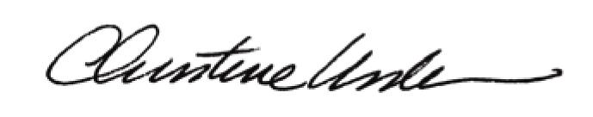

By:

Date of Meeting: May 18, 2015 Title: Historic Officer

